**MUSIC STORE DATA ANALYSIS USING SQL**



**SOURCE:https://m.media-amazon.com/images/W/IMAGERENDERING_521856-T1/images/I/61YNkwn+VyL.jpg**

**This report is an Exploratory data analysis on the Chinook Music Database,**

**SQL TABLE SCHEMA**

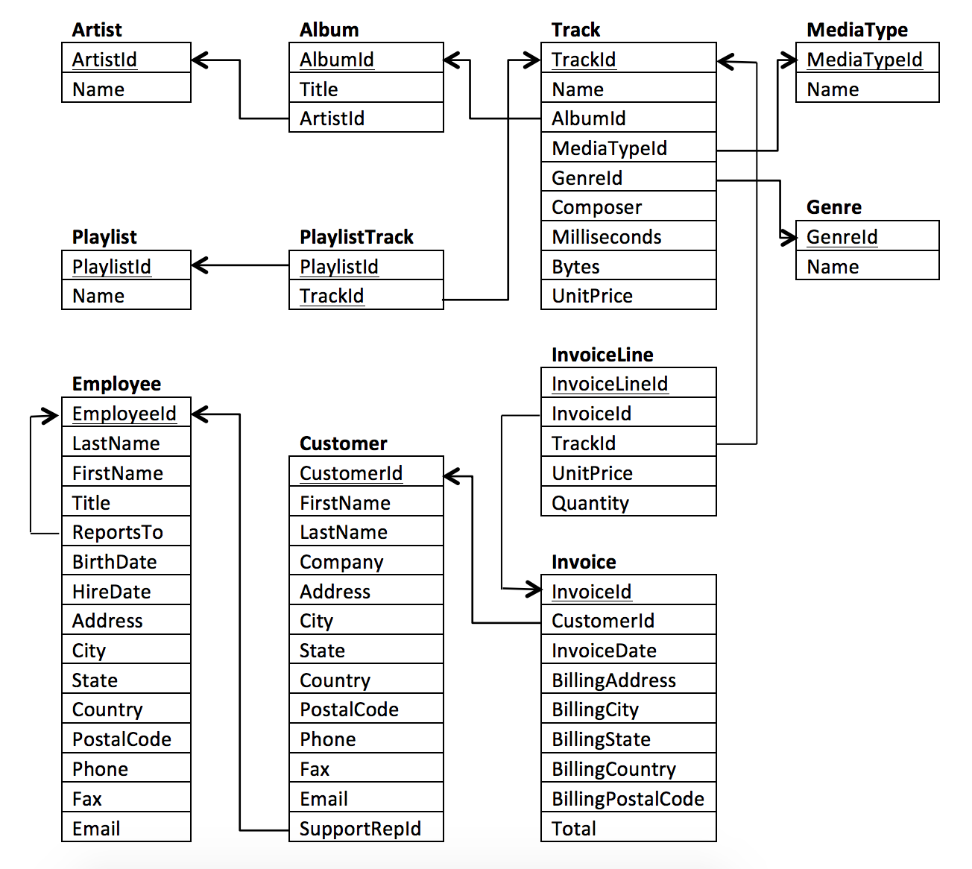

**MUSIC DATA ANALYSIS**

|  |  |  |  |
| --- | --- | --- | --- |
| **Number of Artists** | **Number of Albums** | **Number of Tracks** | **Number of Genres** |
| 275 | 347 | 3497 | 25 |

* **Top 10 Countries with the greatest number of invoices**
* **TOP 10 Customers who spent the most on music.**



* **Most popular genre of Canada**

Let’s say that the genre that is purchased the most would be the most loved or popular genre in Canada.

* **Are there any customers who have bought music from every genre?**

**Customers who bought music from more than 10 genres**



* **Most popular genre in each Country**



* **Track of the Year**

**Looks like War Pigs have won the war of being the most popular track of the year for three consecutive years as it was purchased the maximum number of times in 2017, 2018 and 2019.**



* **Most Popular Track of all time**

**War Pigs tops the chart with the greatest number of times the track purchased.**

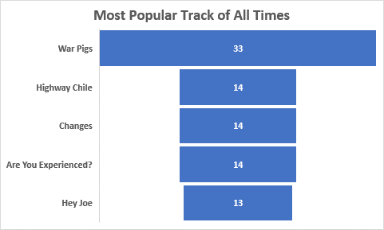

* **Top 5 Selling Artist**

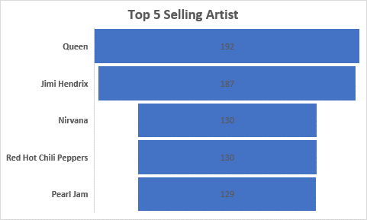

* **Which Media tops the Charts?**

**Clearly MPEG audio file tops the chart as it is being purchased more than 4000 times.**

**SALES BASED ANALYSIS**

* **Most Successful Sales Agent**
* **Who reports to whom?**

